**Lab 05**

**[CLO-02 & 03, PLO-05 & 09, P3(Guided Response) & A2(Responding), Rubric (Simulation & Team Work)]**

**Introduction to DC power supply, designing and simulating the 12v DC power supply on Proteus**

1. **Introduction to DC Power Supply**

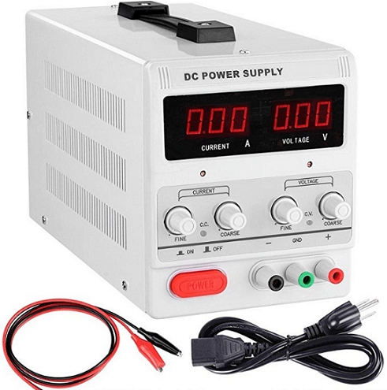

A DC (Direct Current) power supply is an electrical device that converts alternating current (AC) from a power source, such as an electrical outlet, into direct current suitable for powering electronic devices. DC power supplies play a crucial role in providing a stable and regulated voltage to ensure proper operation of electronic circuits and components.

Here's a brief introduction to DC power supplies:

1. **Purpose:** The primary purpose of a DC power supply is to provide a constant and regulated DC voltage to electronic devices. This stability is essential for the reliable operation of various electronic components like integrated circuits, microcontrollers, and sensors.
2. **Types of DC Power Supplies:**
   * **Linear Power Supplies:** These use linear regulators to control the output voltage. They are simpler but less energy-efficient.
   * **Switched-Mode Power Supplies (SMPS):** These are more complex but offer higher efficiency by rapidly switching the input voltage on and off.
3. **Components:**
   * **Transformer:** Converts AC voltage from the main power source to a different voltage.
   * **Rectifier:** Converts AC to pulsating DC.
   * **Filter:** Smoothens the pulsating DC to reduce voltage ripple.
   * **Regulator:** Maintains a constant output voltage.
4. **Voltage Regulation:**
   * **Fixed Voltage Supplies:** Provide a constant, unchangeable voltage.
   * **Variable Voltage Supplies:** Allow the user to adjust the output voltage within a specified range.
5. **Applications:**
   * **Electronics Labs:** Used for testing and prototyping electronic circuits.
   * **Electronic Devices:** Powering various devices such as routers, modems, and microcontrollers.
   * **Communication Systems:** Providing stable power to communication equipment.
6. **Safety Measures:**
   * DC power supplies often incorporate safety features such as overcurrent protection and overvoltage protection to prevent damage to connected devices.

**Lab Task 01**

**Comply** the task in group and, **Try** to simulate the given circuit in proteus and also implement on hardware using bread board.

**[CLO-02 & 03, PLO-05 & 09, P3(Guided Response) & A2(Responding), Rubric (Simulation & Team Work)]**

**Rubric:**

|  |  |  |  |  |
| --- | --- | --- | --- | --- |
| **Marks** | **1** | **2** | **3** | **4** |
| **Simulations** | The simulation is not as per guidelines and requirements are not met | Some section of code simulation is correct | Most section of simulation is correct and understands it well | The simulation is properly done, and have good understanding about it |
| **Team Work** | Rarely listens to, shares with, and supports the efforts of others. Often is not a good team member. | Often listen to, shares with and supports the efforts of others, but sometimes is not good team member. | Usually listen to, shares with, and supports the efforts of others. Usually, respectful and listening actively | Almost always listens to, shares with and supports the efforts of others. Tries to keep people working well together. |

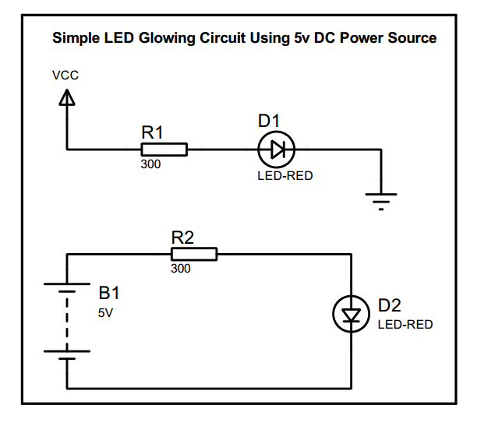

**Lab Task 02**

**Comply** the task in group and, **Try** to simulate the given circuit in proteus and also implement on hardware using bread board.

**[CLO-02 & 03, PLO-05 & 09, P3(Guided Response) & A2(Responding), Rubric (Simulation & Team Work)]**

**Rubric:**

|  |  |  |  |  |
| --- | --- | --- | --- | --- |
| **Marks** | **1** | **2** | **3** | **4** |
| **Simulations** | The simulation is not as per guidelines and requirements are not met | Some section of code simulation is correct | Most section of simulation is correct and understands it well | The simulation is properly done, and have good understanding about it |
| **Team Work** | Rarely listens to, shares with, and supports the efforts of others. Often is not a good team member. | Often listen to, shares with and supports the efforts of others, but sometimes is not good team member. | Usually listen to, shares with, and supports the efforts of others. Usually, respectful and listening actively | Almost always listens to, shares with and supports the efforts of others. Tries to keep people working well together. |

Top of Form

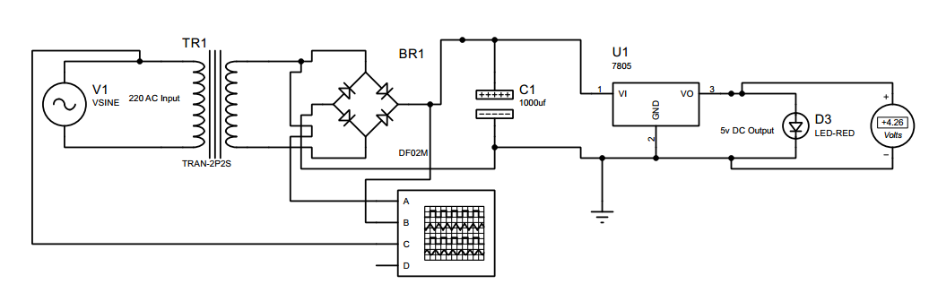

**Hardware Components Required:**

* 12v 1 Amp Transformer (1)
* W10 Bridge Rectifier (1)
* 1000 uF 25v Capacitor (1)
* 7805 Voltage Regulator (1)
* Wire (1 meter)
* Plug (2 pin)

**Lab Report Rubric:** *must be submitted in next lab***.**

|  |  |  |  |  |
| --- | --- | --- | --- | --- |
| **Marks** | **1** | **2** | **3** | **4** |
| **Lab Report** | The lab report does not follow the guidelines for formatting. | Presents some sections of the lab in the correct order. Three or more sections are not in the correct order; missing heading or title; | Presents most sections of the lab in the correct order, one or two sections may not be in the correct order; heading or title missing or not complete; | Presents all the sections of the lab in the correct order with correct formatting: includes correct heading, section headings and title of lab; |

Top of Form